CHAPTER NO 12

INTRODUCTION TO WINDOWS

WHAT IS WINDOWS?
DEFINATION:
“Microsoft windows is an operating system for personal computers and users. It is developed by Microsoft Corporation. Many of computers are working with the windows operating system. Remaining computers use Linux or Macintosh operating systems.”
Windows work with GUI (Graphical User Interface) in which we have a cursor and a screen to operate computer with the help of peripheral devices.

HOW TO START A COMPUTER

- On the front of the system unit you will find the start button which has a symbol like this on it:

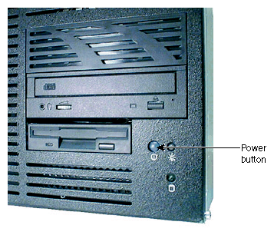

(Fig: Start Button)

- Press it firmly and then let go.
- You will also need to turn on the monitor by pressing a button with a similar symbol on it:
- The computer then starts the process of ‘booting up’

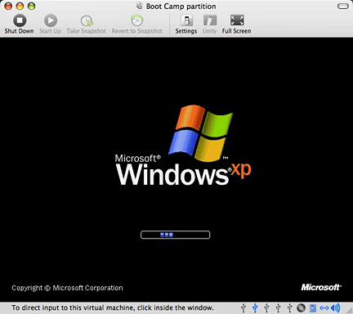

- In order to start up successfully the computer first has to check that all it’s’ parts are working properly. You can hear the computer working away at this task, and see text on the screen which tells you what is happening.
- The computer then has to load the Operating System the instructions that help it to run other programs.
- Once this process is completed successfully you will see the Windows start up screen which tells you which version of the operating system is running e.g. Windows XP or Windows Vista.

- Finally, you will see the Windows desktop screen & Taskbar and you will know that the computer is ready for use…

USING THE MOUSE AND CURSOR
The mouse when you move the mouse on the table, you will see the cursor moving on screen.
Put your hand on the mouse so you can move it around on the table and also click the buttons with your fingers.
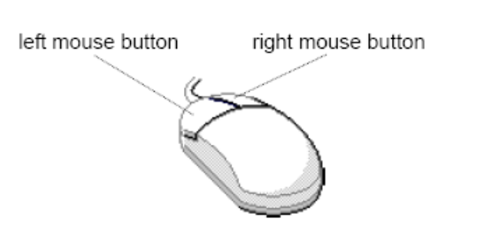

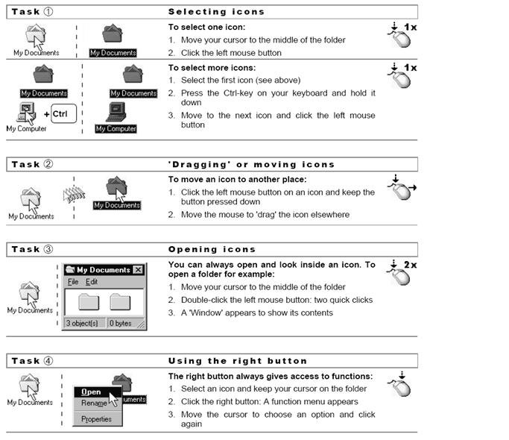

FEATURES OF WINDOWS

GRAPHICAL USER INTERFACE:
Windows using graphical user interface environment that simplifies the user's interaction with the computer by representing programs, commands, files, and other options as visual elements, such as icons, pull-down menus, buttons, scroll bars, windows, and dialog boxes.
START BUTTON
On very left corner a Start button is located in windows. By clicking it we can access many of the main programs within the computer. It is very easy way to interact by computer programs just click on start button and access these programs like open a document, paint, calculator, manage files , maintain systems and many more.
TASK BAR

In the bottom section of the screen, there is (or there may be) a long bar. It is called the Taskbar:
On the left side of the taskbar, there is an object labeled Start or . The appearance of this object depends on the type of Windows you are using but it plays the same role.
On the right side of Start, there is a wide area that is empty when the computer starts. This is actually referred to as the taskbar.
In some versions (Windows 95, 98, Windows Server 2003), the color of the taskbar may be gray (or Silver). In some other versions (Windows Millennium), the taskbar may be yellowish. In Windows XP, it may be blue.
On the far right side of the taskbar is a section called the tray area. One of the things that this area displays is the current time (as set on your computer).

ICONS
Icons are small graphical images that can represent your computer's programs, files, folders and printers amongst other things.
To activate the program/file/folder that an icon represents you simply double click (two clicks in quick succession) on it with the left mouse button. This will activate the icon and either start a program or open a file/folder.
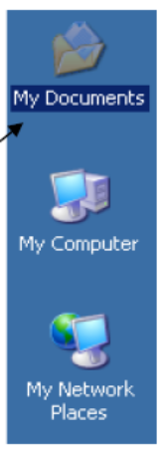
The icons on your desktop can be renamed by right clicking on them and selecting rename. They can be deleted by right clicking and selecting delete. It's possible to create your own Windows desktop icons for programs, files, folders, etc.
Examples of icons are
- My computer
- My document
- Recycle bin
- Shortcut

MY COMPUTER:
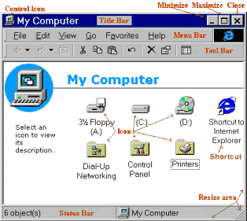
My computer icon has information displays all the components of the computer including disk drives and networks all parts of the computer can be accessed through My Computer's hierarchical structure double click on any icon to view the contents of a disk, folder or run a program.

(Fig: my computer)

MY DOCUMENT:
My Documents is the name of a special folder on the computer's hard disk that the system commonly uses can store his documents, music, pictures, downloads, and other files.
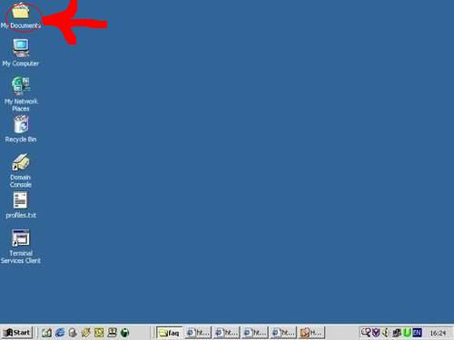

(Fig: My Document)
RECYCLE BIN:
When you delete a file, Windows XP will place the file into the recycle bin (instead of deleting it altogether), this allows you to restore the file in case you deleted it by mistake.
For example, if you deleted a file by accident you could double click on the recycle bin icon to see its contents. Inside you will see the file/folder that you deleted, to restore the file back to where you deleted it from, right click on it and then select restore from the menu that appears.
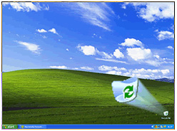

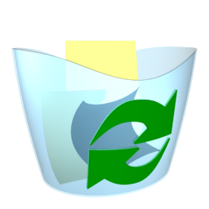

(Fig: Recycle bin)
DESKTOP
After you have started the computer, the area you are looking at is called the desktop. The desktop is usually different from one computer to another. This is because some items get added as new programs are installed on a computer, and other items get deleted at will. Eventually, you will know how to change the way your desktop looks.
The Microsoft Windows desktop is made of various parts. From the upper left to the lower left side of the screen, there are small pictures or images called icons. Each one is used to make the computer do something. Here is an example:

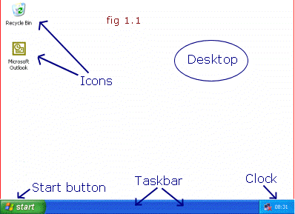

(Fig: Desktop)

HOW TO MANAGE AND CUSTOMIZE YOUR DESKTOP APPEARANCE
Lots of computer users just leave their desktop with the default windows settings, but if you are a little bit creative and want your computer to be more "you", you have various options for customization.
To get to where you make changes to the look & feel
- Right-click on an empty area of your desktop
- Click Properties
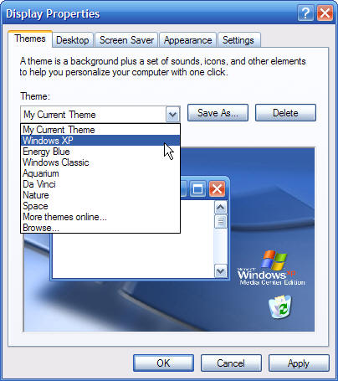

From the drop-down menu under the "Themes" tab, you can choose a Theme. A theme will give you a background and a set of sounds, Icons and other elements that will change the Look & feel.
You don't have to choose a Theme - you can also make your own settings.

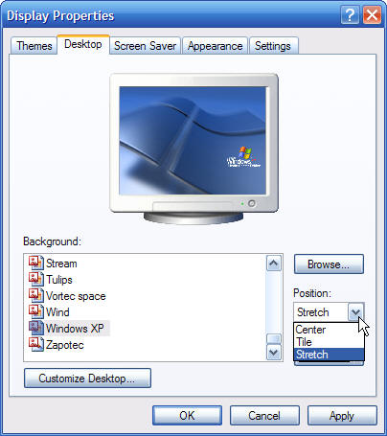

From the Desktop tab in your properties window you can choose between many different pre-installed patterns and pictures. Scroll through them and pick one, if you can find one you like. The images have different proportions, so you get another option on the right hand side of the window. You can choose to:
- Center the image
- Tile the image
- or Stretch the image
If you have a picture stored on your computer, you can choose to add you own picture to the list and use it as a wallpaper image.
- Click the browse button on the right side of the window
- In the drop-down menu on top of the window choose the location of your picture
- Select the picture by clicking on it
- Click open

THE SCREEN SAVER

A screen saver is a moving design that appears on a computer screen when there has been no input for a specified period of time. Screen savers prevent the damage that occurs when the same areas of light and dark are displayed too long.
It would actually take many hours to burn in an image on today's color monitors, but a lot of people find screen savers nice to look at and it "covers" up your work, if you have to leave the computer for a while.
Pressing a key or moving the mouse restores the screen.
To change the look of your screen saver choose the "Screen saver" tab in your desktop properties window.

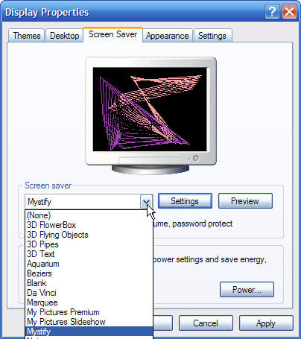

From the drop-down menu choose one of the pre-installed screen savers. When you click on the screen savers in the menu, you will be able to preview, what it looks like. You can see a small sample desktop inside the window - or you can click the "preview" button to the right and see what it would look like on your monitor. To get out of the preview mode, simply click once anywhere on the screen.
Another thing you are able to change is how your windows and buttons look, as well as the size of the font.
- CLICK THE APPEARANCE TAB
Depending on which Windows operating system you are using, you will find several choices in font-sizes and styles the drop-down menu.
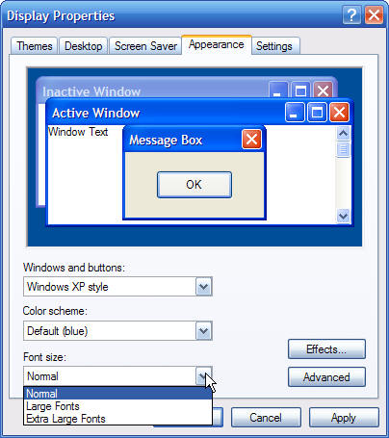

START BUTTON AND START MENU:
The Start Button starts programs, opens documents, and access most parts of the system. Windows Program menus can be customized as needed.
- Program displays a list of the programs that are installed through Windows available to use.
- Documents displays a list of the last 15 documents used allowing the user to open them directly from this menu
- Settings displays system components, such as printers, control panel and taskbar
- Find/Search has search abilities to find files, folders and phrases in documents on your computer
- Help displays help topics broken up into contents, index and find components
- Run allows you to start a program from a command line
- Shut down shuts down the computer, restarts the computer or logs you off a network
- Favorites and Active Desktop is an option available to Windows 98+ (or Internet Explorer 4x) users.
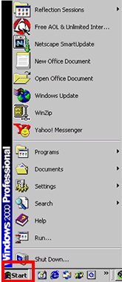

DETAILS

PROGRAMS

The program contains a list of programs that are installed and store in your computer while you installed your operating system. All programs contain many sub options like:
- Accessories: calculator, paint, word pad, Note pad and command prompt etc.
- Internet explorer: a web browser to explore web site on internet.
- Ms. Office: Very important application software contains, Ms. Word, Excel and Power point.

DOCUMENTS:

This option contains the resent copies of files. It displays a list of the last 15 documents used allowing the user to open them directly from this menu and it is updated after some time whenever user modify or changed file.

CONTROL PANEL & SYSTEM PREFERENCES
Control panel is used for setting hardware, programs, software and drivers of all components of system. It is used to change system settings like screen savers, time, screen colors.
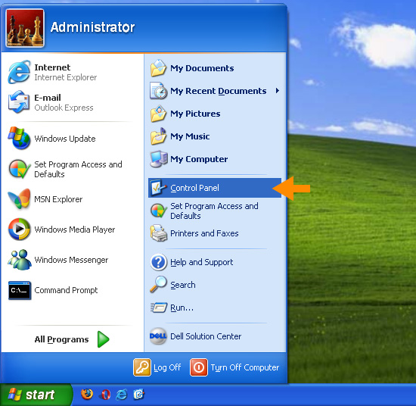
It is also used to add and remove programs, fonts add and make changes to hardware and software settings.

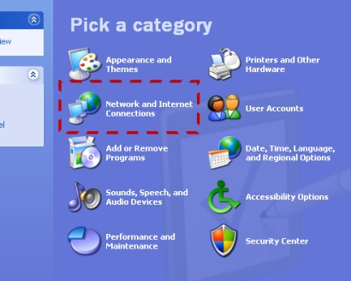

USING HELP
Help is to get help about a specific procedure click the help button in the top right corner of the screen
- Contents list general topics grouped by subject
- Index list specific topics accessed by scroll bars or typing the topic
- Find creates an index of words in Help and allows searches by word or phrase
- click Help Topics to return to the Help menu
- Troubleshooters will step you through a series of steps to solve computer problems.

SEARCH
To search for a file or folder:
- Click Start, and then click Search.
- In the Search Companion dialog box, click All files and folders.
- Type part or all of the name of the file or folder, or type a word or phrase that is in the file.
- In the Look in box, click the drive or drives, folder, or network location that you want to search.
- Choose one of the following options:
  - Click When was it modified to look for files that were created or modified on or between specific dates.
  - Click What size is it to look for files that are specific size.
  - Click More advanced options to specify additional search criteria.
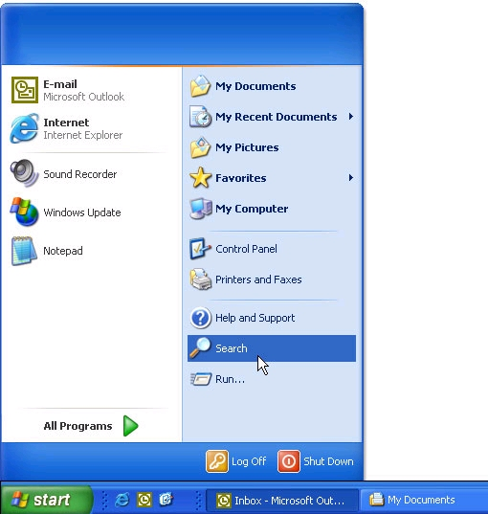
- Click Search.

TURN OFF COMPUTER:

- Close all programs that you have open, by clicking on the close button in the top right hand corner of the screen.
- Don’t forget to close any programs that you have open, but minimized, on the task bar at the bottom of the screen:

- One of the strange things about the PC is that you stop it from the Start Menu.

- Using your mouse click on the Start button in the bottom left hand corner of the screen which opens the start menu.
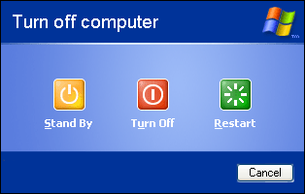

- Click on Turn Off Computer button
- Click on the Turn off button.
- This will complete the process of closing down the PC, but just as the computer takes time to boot up, so the shutting down process takes time as the computer shuts down all its’ operations safely.

